**Use Case Diagrams**

This section outlines the use cases for each of the actors separately. The relevant actors of the software are the Donor, the Needy and the Administrative body.

1. **The donor use case**

Donor

**Brief Description:** A donor who wishes to use WEcare software to carry out his/her donations should first create a user account providing all the necessary identity verification details. After that, he/she can submit their donations by providing necessary information about the donating resources. Once, one of his/her donation is completed, the donor receives a report describing the details of the donation.

1. **The needy use case**

Needy

**Brief Description:** A person who wishes to use WEcare software to find reused resources should first create a user account providing all the necessary identity verification details. After that, he/she can view available donations and submit requests or cancel request for desired donating resources. The user gets a message if he/she has been able to receive the requested donation.

1. **The Administration use case**

Administration

**Brief Description:** The administration of WEcare software, connect the needy and the customer. Administration should verify the details of the donor and needy accounts, listing and categorizing the donations, allocating the donations to the correct needy. Once the donations is received by the needy, administration should provide a receipt to the donor, to confirm the donation has been handed over for the required people

**UML Class Diagrams**

1. **Donation client  application**

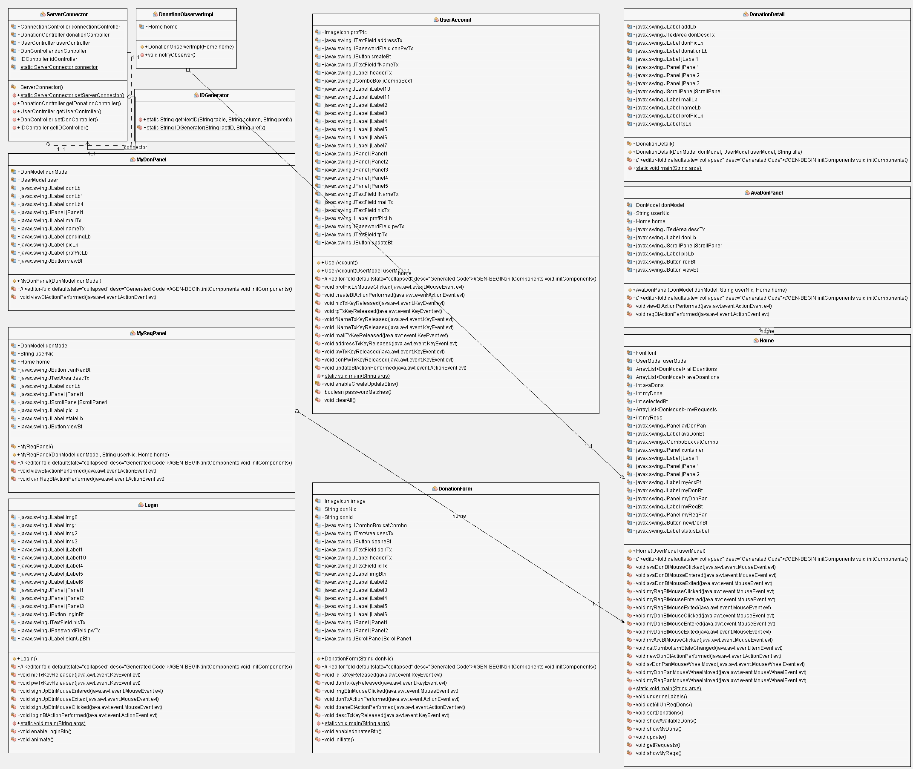

1. **Donation server application**

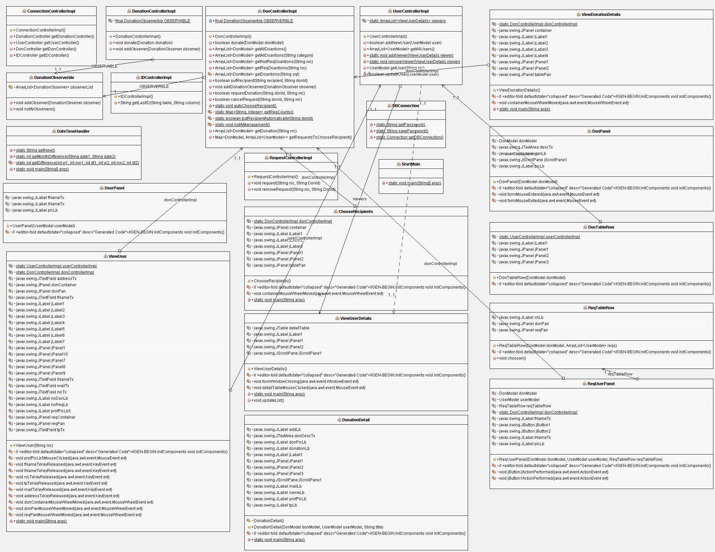

1. 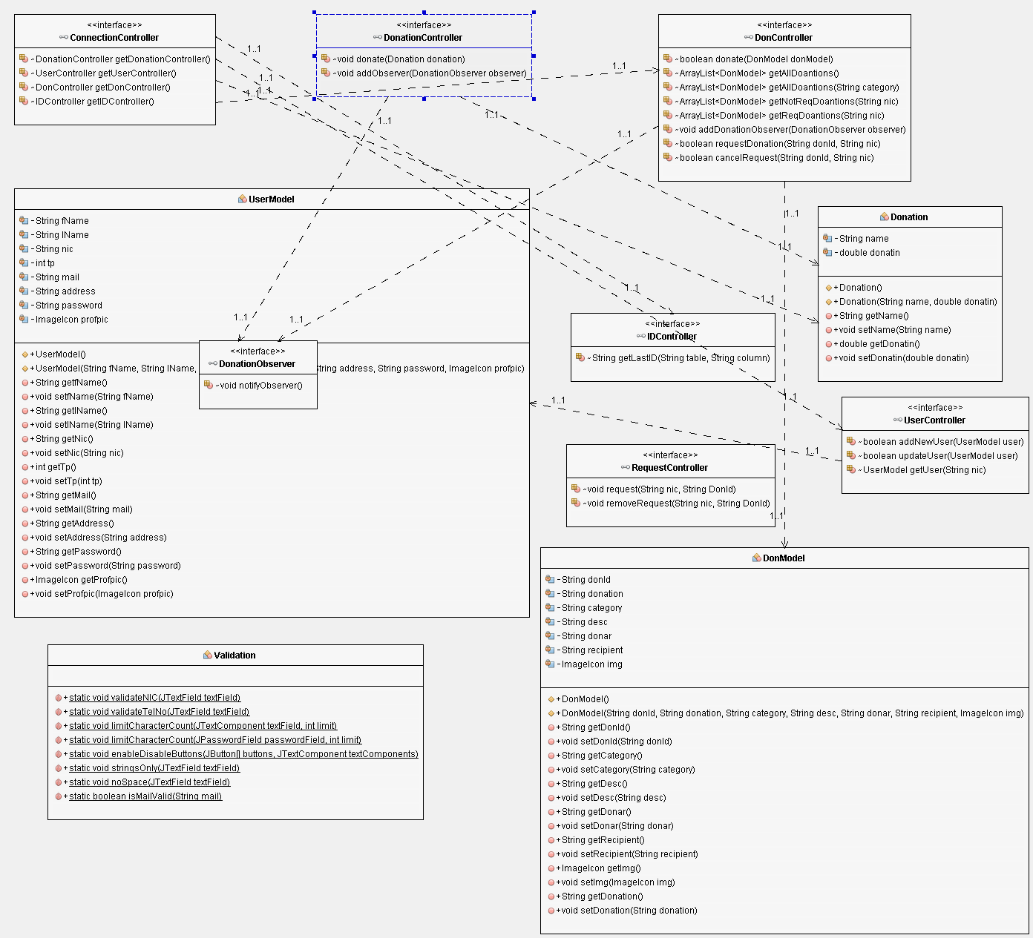**Donation common application**